**Hospital Network system**

|  |  |  |
| --- | --- | --- |
| **Sno.** | **Name** | **Student ID** |
| 1. | Anas Subzwari | 11321 |
| 2. | Muhammad Ahsan | 11450 |
| 3. | Muzammil khan | 11508 |

**Problem:**

Slow and Inefficient University Network Connectivity.

**Problem Description:**

There are issues with the hospital's current network infrastructure, including poor connectivity and ineffective data transmission. When carrying out any kind of research, using internet resources, handing in assignments, or working with doctors or staff, there are frequent delays. The current network configuration can't keep up with the rising demands of a sizable hospital body, which frustrates users and reduces productivity.

**Problem Solution:**

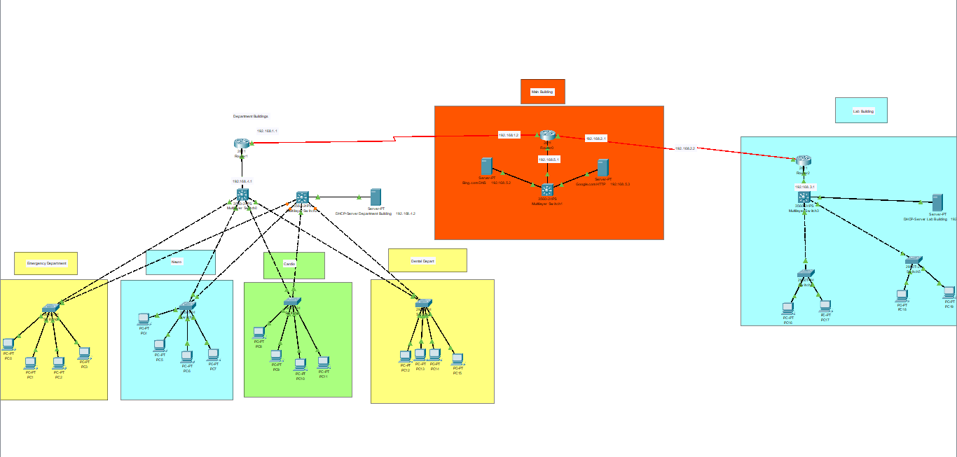

**Solution Description:**

We have main building in the hospital where the web server and the dns server and there is two buildings having different departments in building 1 there is dhcp server which gives auto ips to the pcs of the depaartmnet users.